Supporting Information
Rec. Nat. Prod. X:X (202X) XX-XX
Bioguided Isolation of Secondary Metabolites from Salvia cerino-pruinosa Rech. f. var. cerino-pruinosa

Abdulselam Ertas¹, Hatice Cakirca¹, Ismail Yener², Mehmet Akdeniz³, Mehmet Firat⁴, Gulacti Topcu⁵, Ufuk Kolak⁶*
¹Department of Pharmacognosy, Faculty of Pharmacy, Dicle University, 21280 Diyarbakir, Turkey
²Department of Analytical Chemistry, Faculty of Pharmacy, Dicle University, 21280 Diyarbakir, Turkey
³The Council of Forensic Medicine, Ministry of Justice, 21100 Diyarbakir, Turkey
⁴Department of Biology, Faculty of Education, Van Yüzüncü Yıl University, 65080 Van, Turkey
⁵Department of Pharmacognosy and Phytochemistry, Bezmialem Vakif University, 34093 Istanbul, Turkey
⁶Department of General and Analytical Chemistry, Faculty of Pharmacy, Istanbul University 34116 Istanbul, Turkey
Table of Contents | Page
Table S1. Antioxidant activity of the fractions obtained from the aerial parts and roots ethanol extracts of S. cerino-pruinosa var. cerino-pruinosa with fraction solvent system and their quantity | 4
Table S2. Isolated compounds (1-20) | 5
Figure S1. Chemical formulae of the isolated compounds | 6
Figure S2. ¹H NMR spectrum of 1 in CD₃OD (600 MHz) | 7
Figure S3. ¹³C NMR (APT) spectrum of 1 in CD₃OD (150 MHz) | 7
Figure S4. LC-MS-IT-TOF spectrum of 1 | 8
Figure S5. IR spectrum of 1 | 8
Figure S6. ¹H NMR spectrum of 2 in CD₃OD (600 MHz) | 9
Figure S7. ¹³C NMR (APT) spectrum of 2 in CD₃OD (150 MHz) | 9
Figure S8. LC-MS-IT-TOF spectrum of 2 | 12
Figure S9. IR spectrum of 2 | 12
Figure S10. ¹H NMR spectrum of 3 in CD₃OD (600 MHz) | 13
Figure S11. ¹³C NMR (APT) spectrum of 3 in CD₃OD (150 MHz) | 13
Figure S12. LC-MS-IT-TOF spectrum of 3 | 14
Figure S13. IR spectrum of 3 | 14
Figure S14. ¹H NMR spectrum of 4 in CD₃OD (600 MHz) | 15
Figure S15. ¹³C NMR (APT) spectrum of 4 in CD₃OD (150 MHz) | 15
Figure S16. LC-MS-IT-TOF spectrum of 4 | 16
Figure S17. IR spectrum of 4 | 16
Figure S18. ¹H NMR spectrum of 5 in CD₃OD (600 MHz) | 17
Figure S19. ¹³C NMR (APT) spectrum of 5 in CD₃OD (150 MHz) | 15
Figure S20. LC-MS-IT-TOF spectrum of 5 | 16
Figure S21. ¹H NMR spectrum of 6 in CD₃OD (600 MHz) | 16
Figure S22. ¹³C NMR (APT) spectrum of 6 in CD₃OD (150 MHz) | 17
Figure S23. HMQC spectrum of 6 in CD₃OD (600 MHz)  Figure S24. LC-MS-IT-TOF spectrum of 6 | 17  18
Figure S 25.¹H NMR spectrum of 7 in CDCl₃ (600 MHz) | 18
Figure S 26. ¹³C NMR (APT) spectrum of 7 in CDCl₃ (150 MHz) | 19
Figure S27. LC-MS-IT-TOF spectrum of 7 | 19
Figure S28. IR spectrum of 7 | 20
Figure S29. GC-MS spectrum of 7 | 22
Figure S30. ¹H NMR spectrum of 8 in CD₃OD (600 MHz) | 23
Figure S31. ¹³C NMR (APT) spectrum of 8 in CD₃OD (150 MHz) | 23
Figure S32. LC-MS-IT-TOF spectrum of 8 | 24
Figure S33. ¹H NMR spectrum of 9 in CD₃OD (600 MHz) | 24
Figure S34. ¹³C NMR (APT) spectrum of 9 in CD₃OD (150 MHz) | 25
Figure S35. LC-MS-IT-TOF spectrum of 9 | 25
Figure S36. IR spectrum of 9 | 26
Figure S37. ¹H NMR spectrum of 10 in CDCl₃ (600 MHz) | 26
Figure S38. ¹³C NMR (APT) spectrum of 10 in CDCl₃ (150 MHz) | 27
Figure S39. GC-MS spectrum of 10 | 27
Figure S40. LC-MS-IT-TOF spectrum of 10 | 28
Figure S41. IR spectrum of 10 | 28
Figure S42. ¹H NMR spectrum of 11 in CDCl₃ (600 MHz) | 29
Figure S43. ¹³C NMR spectrum of 11 in CDCl₃ (150 MHz) | 27
Figure S44. ¹³C NMR (APT) spectrum of 11 in CDCl₃ (150 MHz) | 30
Figure S45. HMBC spectrum of 11 in CDCl₃ (600 MHz) | 30
Figure S46. HQBC spectrum of 11 in CDCl₃ (600 MHz) | 31
Figure S47. GC-MS spectrum of 11 | 31
Figure S48. LC-MS-IT-TOF spectrum of 11 | 32
Figure S49. IR spectrum of 11 | 32
Figure S50. ¹H NMR spectrum of 12 in CDCl₃ (600 MHz) | 33
Figure S51. ¹³C NMR (APT) spectrum of 12 in CDCl₃ (150 MHz) | 33
Figure S52. HMBC spectrum of 12 in CDCl₃ (600 MHz) | 34
Figure S53. HMQC spectrum of 12 in CDCl₃ (600 MHz) | 34
Figure S54. GC-MS spectrum of 12 | 35
Figure S55. LC-MS-IT-TOF spectrum of 12 | 35
Figure S56. ¹H NMR spectrum of 13 in CDCl₃ (600 MHz) | 36
Figure S57. ¹³C NMR (APT) spectrum of 13 in CDCl₃ (150 MHz) | 36
Figure S58. GC-MS spectrum of 13 | 37
Figure S59. LC-MS-IT-TOF spectrum of 13 | 37
Figure S60. ¹H NMR spectrum of 14 in CDCl₃ (600 MHz) | 38
Figure S61. GC-MS spectrum of 14 | 38
Figure S62. LC-APCI-MSI spectrum of 14 (NEG) | 39
Figure S63. ¹H NMR spectrum of 15 in CDCl₃ (600 MHz) | 39
Figure S64. ¹³C NMR spectrum of 15 in CDCl₃ (125 MHz) | 40
Figure S65. LC-MS-IT-TOF spectrum of 15 | 40
Figure S66. ¹H NMR spectrum of 16 in CDCl₃ (600 MHz) | 41
Figure S67. ¹³C NMR (APT) spectrum of 16 in CDCl₃ (600 MHz) | 41
Figure S68. LC-MS-IT-TOF spectrum of 16 | 42
Figure S69. IR spectrum of 16 | 42
Figure S70. ¹H NMR spectrum of 17 in CDCl₃ (400 MHz) | 43
Figure S71. ¹³C NMR spectrum of 17 in CDCl₃ (400 MHz) | 41
Figure S72. ¹³C NMR (APT) spectrum of 17 in CDCl₃ (150 MHz) | 42
Figure S73. GC-MS spectrum of 17 | 42
Figure S74. LC-MS-IT-TOF spectrum of 17 | 45
Figure S75. ¹H NMR spectrum of 18 in CDCl₃ (600 MHz) | 45
Figure S76. ¹³C NMR (APT) spectrum of 18 in CDCl₃ (150 MHz) | 46
Figure S77. GC-MS spectrum of 18 | 46
Figure S78. LC-MS-IT-TOF spectrum of 18 | 47
Figure S79. IR spectrum of 18 | 47
Figure S80. ¹H NMR spectrum of 19 in CDCl₃ (600 MHz) | 48
Figure S81. ¹³C NMR spectrum of 19 in CDCl₃ (150 MHz) | 48
Figure S82. HMBC spectrum of 19 in CDCl₃ (600 MHz) | 49
Figure S83. HMQC spectrum of 19 in CDCl₃ (600 MHz) | 49
Figure S84. ¹³C NMR (APT) spectrum of 19 in CDCl₃ (150 MHz) | 50
Figure S85. GC-MS spectrum of 19 | 48
Figure S86. LC-MS-IT-TOF spectrum of 19 | 49
Figure S87. ¹H NMR spectrum of 20 in CDCl₃ (600 MHz) | 49
Figure S88. ¹³C NMR (APT) spectrum of 20 in CDCl₃ (150 MHz) | 50
Figure S89. LC-MS-IT-TOF spectrum of 20 | 50

Table S1. Antioxidant activity of the fractions obtained from the aerial parts and roots ethanol extracts of S. cerino-pruinosa var. cerino-pruinosa with fraction solvent system and their quantity
Aerial part |  |  |  | IC₅₀ (µg/mL)*
No | Fraction code | Solvent System | Quantity (g) | DPPH |  | ABTS |  | A_{0.5} (µg/mL)
1 | SCCAPE 1-10 | (100%PE)-(80%PE-%20DCM) | 2.4798 | >1000 |  | >1000 |  | 611.00±5.12
2 | SCCAPE 12-22 | (60%-40%PEDCM)-(80%DCM-20%PE) | 4.7373 | >1000 |  | >1000 |  | 116.41±2.09
3 | SCCAPE 23-28 | (90%DCM-10%PE) | 3.0402 | >1000 |  | >1000 |  | 196.78±2.34
4 | SCCAPE 29-37 | (100%DCM) | 1.8108 | >1000 |  | >1000 |  | 103.30±1.09
5 | SCCAPE 38-40 | (90%DCM-10%AC) | 3.557 | >1000 |  | 167.95±3.45 |  | 65.68±0.87
6 | SCCAPE 41-47 | (90%DCM-10%AC)-(80%DCM-20%AC) | 2.6179 | 117.47±1.96 |  | 26.80±0.42 |  | 35.35±0.45
7 | SCCAPE 48-53 | (40%AC-60%DCM) | 8.0985 | 68.94±1.39 |  | <10 |  | 3.98±0.012
8 | SCCAPE 54-60 | (60AC%-40%DCM)-(80%AC-20%DCM) | 6.7235 | 20.14±0.54 |  | <10 |  | 17.40±0.23
9 | SCCAPE 61-64 | (100%AC) | 3.9706 | 25.06±0.90 |  | 23.57±0.54 |  | 30.38±0.34
10 | SCCAPE 65-69 | (90%AC-10%MeOH)-(40%MeOH-60AC%) | 11.9675 | 44.97± 1.95 |  | <10 |  | 11.91±0.14
11 | SCCAPE 70-75 | (60%MeOH-40%AC) | 20.7084 | 9.97 ± 0.37 |  | 14.22±0.38 |  | 52.19±1.23
12 | SCCAPE 76-79 | (80%MeOH-20%AC) | 2.4452 | 37.95 ± 0.82 |  | <10 |  | 13.31±0.21
13 | SCCAPE 80-85 | (100%MeOH) | 3.0184 | 22.34 ± 0.69 |  | 17.31±0.58 |  | 28.12±0.87
14 | SCCAPE 86-88 | (90%MeOH-10%H₂O)-(50%MeOH-50%H₂O) | 3.6503 | 32.60 ± 0.22 |  | 17.68±1.07 |  | 32.31±0.94
Root
1 | SCCRE 1-10 | (100%PE)-(80%PE-20%DCM) | 0.2134 | >1000 | >1000 |  | 282.00±2.23
2 | SCCRE 11-12 | (60%PE-40%DCM) | 0.1275 | >1000 | >1000 |  | 161.84±1.56
3 | SCCRE 13-17 | (60%PE-40%DCM)-( 40%PE-60%DCM) | 1.0469 | 546.90 ± 24.89 | 71.08±2.12 |  | 77.71±1.09
4 | SCCRE 18-24 | (80%DCM-20%PE)-( 90%DCM-10%PE) | 2.8925 | 54.368±0.69 | 26.96±0.29 |  | 34.47±0.98
5 | SCCRE 25-28 | (90%DCM-10%PE) | 2.9271 | 54.19±1.12 | 25.57±0.35 |  | 14.51±0.56
6 | SCCRE 29-34 | (100DCM%) | 1.0736 | 136.54±2.79 | 60.66±0.44 |  | 57.74±1.12
7 | SCCRE 35-39 | (90%DCM-10%AC) | 5.3850 | 73.09±1.28 | 73.25±1.88 |  | 141.96±2.34
8 | SCCRE 40-44 | (90%DCM-10%AC)-(80%DCM-20%AC) | 1.5822 | 188.72±5.14 | 129.60±4.09 |  | 57.80±1.09
9 | SCCRE 45-50 | (60%DCM-40%AC)-( 40%DCM-60%AC) | 3.1429 | 122.29±2.02 | <10 |  | 10.03±0.03
10 | SCCRE 51-55 | (40%DCM-60%AC)-(80%AC-20%DCM) | 2.5746 | 28.60±1.06 | 34.05±0.99 |  | 32.92±0.78
11 | SCCRE 56-63 | (100%AC)-(40%MeOH-60%AC) | 4.1419 | 73.92±0.79 | 94.51±2.07 |  | 104.18±1.45
12 | SCCRE 64-70 | (60%MeOH-40%AC)-( 80%MeOH-%20AC) | 3.1322 | 231.05±11.93 | 148.01±0.16 |  | 192.74±3.32
13 | SCCRE 71-77 | (100%MeOH)-(90%MeOH-10%H₂O)-  (50%MeOH-50%H₂O) | 0.1347 | 477.56±8.97 | 141.063±5.18 |  | 217.81±3.78
 | α-TOC | - | - | 9.94±0.12 | 17.20±0.65 |  | 9.34±0.05
 | BHT | - | - | 59.12±1.12 | 12.93±0.84 |  | 5.12±0.02
*: Values expressed are means ± S.D. of three parallel measurements and values were calculated according to a negative control.
SCCAPE: S. cerino-pruinosa var. cerino-pruinosa aerial parts ethanol extract
SCCRE: S. cerino-pruinosa var. cerino-pruinosa roots ethanol extract
PE: Petroleum ether, DCM: Dichloromethane, AC: Acetone
BHT: Butylated hydroxytoluene, α-TOC: α-Tocopherol

Table S2. Isolated compounds (1-20)
Fractions | SCC-APE* | SCC-RE* | Compounds  number | Compounds
SCCAPE-65-69-Prep.HPLC | + | - | 1 | Rosmarinic acid
SCCAPE-65-69 Prep.HPLC | + | - | 2 | Chlorogenic acid
SCCAPE-70-75 Prep.HPLC | + | - | 3 | Caffeic acid
SCCAPE-54-60 Prep.HPLC | + | - | 4 | 4-Hydroxybenzoic acid
SCCAPE-54-60 Prep.HPLC | + | - | 5 | Benzoic acid
SCCAPE-65-69-Prep.HPLC | + | - | 6 | Luteolin 7-O-Glycoside
SCCRE-51-55 | + | + | 7 | Bis-(2-ethylhexyl)benzene-1,2-dicarboxylate
SCCAPE-80-85 Prep.HPLC | + | - | 8 | Salvianolic acid A
SCCAPE-80-85 Prep.HPLC | + | - | 9 | Salvianolic acid B
SCCRE-18-24 (16-18)-9 | - | + | 10 | 7-Acetyl royleanone
SCCRE 25-28-(17-28)-7 | - | + | 11 | 6,7-Dehydroroyleanone
SCCRE-25-28-(17-18)-6 | + | + | 12 | Ferruginol
SCCRE-25-28-(17-18)-11 | - | + | 13 | Inuroyleanol
SCCRE-18-24 (16-18)-15 | - | + | 14 | 12-Hydroxy-6,7-secoabieta-8,11,13-trien-6,7-dial
SCCAPE-48-53 | + | + | 15 | Ursolic acid
SCCRE-45-50 | + | + | 16 | Oleanolic acid
SCCAPE 41-47-(12)-3 | + | - | 17 | Taraxasterol
SCCAPE 41-47-(12)-1 | + | - | 18 | Lupenone
SCCAPE-61-64 | + | + | 19 | β-Sitosterol
SCCRE-35-39 | + | + | 20 | Stigmasterol
*: Some compounds were isolated from both aerial part and root; the most abundant fractions which contain them were indicated in this table. SCCAPE: S. cerino-pruinosa var. cerino-pruinosa aerial parts ethanol extract, SCCRE: S. cerino-pruinosa var. cerino-pruinosa roots ethanol extract, PE: Petroleum ether, DCM: Dichloromethane, AC: Acetone

Figure S1. Chemical formulae of the isolated compounds
Rosmarinic acid (1), Chlorogenic acid (2), Caffeic acid (3), 4-Hydroxybenzoic acid (4), Benzoic acid (5), Luteolin 7-O-Glucoside (6), Bis-(2-ethylhexyl)benzene-1,2-dicarboxylate (7), Salvianolic acid A (8), Salvianolic acid B (9), 7-Acetyl royleanone (10), 6,7-Dehydroroyleanone (11), Ferruginol (12), Inuroyleanol (13), 12-Hydroxy-6,7-secoabieta-8,11,13-trien-6,7-dial (14), Ursolic acid (15), Oleanolic acid (16), Taraxasterol (17), Lupenone (18), β-Sitosterol (19), and Stigmasterol (20).

Figure S2. ¹H NMR spectrum of 1 in CD₃OD (600 MHz)

Figure S3. ¹³C NMR (APT) spectrum of 1 in CD₃OD (150 MHz)

Figure S4. LC-MS-IT-TOF spectrum of 1

Figure S5. IR spectrum of 1

Figure S6. ¹H NMR spectrum of 2 in CD₃OD (600 MHz)

Figure S7. ¹³C NMR (APT) spectrum of 2 in CD₃OD (150 MHz)

Figure S8. LC-MS-IT-TOF spectrum of 2

Figure S9. IR spectrum of 2

Figure S10. ¹H NMR spectrum of 3 in CD₃OD (600 MHz)

Figure S11. ¹³C NMR (APT) spectrum of 3 in CD₃OD (150 MHz)

Figure S12. LC-MS-IT-TOF spectrum of 3

Figure S13. IR spectrum of 3

Figure S14. ¹H NMR spectrum of 4 in CD₃OD (600 MHz)

Figure S15. ¹³C NMR (APT) spectrum of 4 in CD₃OD (150 MHz)

Figure S16. LC-MS-IT-TOF spectrum of 4

Figure S17. IR spectrum of 4

Figure S18. ¹H NMR spectrum of 5 in CD₃OD (600 MHz)

Figure S19. ¹³C NMR (APT) spectrum of 5 in CD₃OD (150 MHz)

Figure S20. LC-MS-IT-TOF spectrum of 5

Figure S21. ¹H NMR spectrum of 6 in CD₃OD (600 MHz)

Figure S22. ¹³C NMR (APT) spectrum of 6 in CD₃OD (150 MHz)

Figure S23. HMQC spectrum of 6 in CD₃OD (600 MHz)

Figure S24. LC-MS-IT-TOF spectrum of 6

Figure S 25.¹H NMR spectrum of 7 in CDCl₃ (600 MHz)

Figure S 26. ¹³C NMR (APT) spectrum of 7 in CDCl₃ (150 MHz)

Figure S27. LC-MS-IT-TOF spectrum of 7

Figure S28. IR spectrum of 7

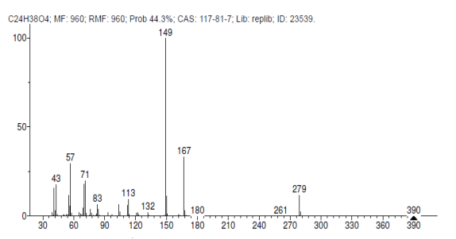
Figure S29. GC-MS spectrum of 7

Figure S30. ¹H NMR spectrum of 8 in CD₃OD (600 MHz)

Figure S31. ¹³C NMR (APT) spectrum of 8 in CD₃OD (150 MHz)

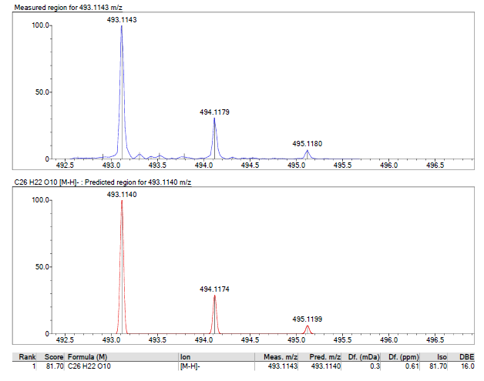
Figure S32. LC-MS-IT-TOF spectrum of 8

Figure S33. ¹H NMR spectrum of 9 in CD₃OD (600 MHz)

Figure S34. ¹³C NMR (APT) spectrum of 9 in CD₃OD (150 MHz)

Figure S35. LC-MS-IT-TOF spectrum of 9

Figure S36. IR spectrum of 9

Figure S37. ¹H NMR spectrum of 10 in CDCl₃ (600 MHz)

Figure S38. ¹³C NMR (APT) spectrum of 10 in CDCl₃ (150 MHz)

Figure S39. GC-MS spectrum of 10

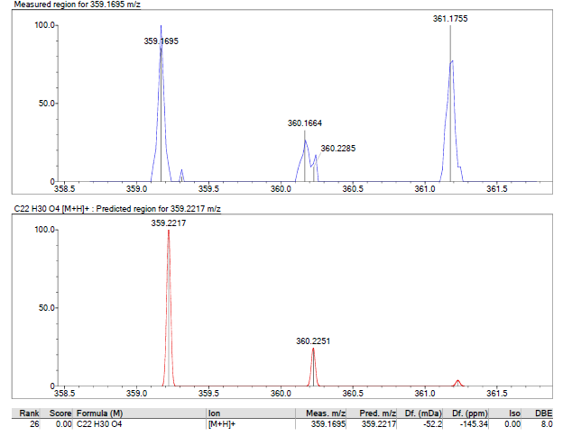
Figure S40. LC-MS-IT-TOF spectrum of 10

Figure S41. IR spectrum of 10

Figure S42. ¹H NMR spectrum of 11 in CDCl₃ (600 MHz)

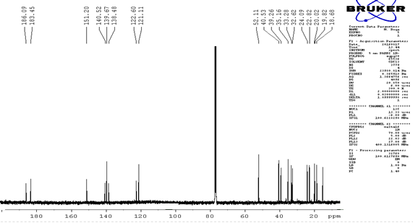
Figure S43. ¹³C NMR spectrum of 11 in CDCl₃ (150 MHz)

Figure S44. ¹³C NMR (APT) spectrum of 11 in CDCl₃ (150 MHz)

Figure S45. HMBC spectrum of 11 in CDCl₃ (600 MHz)

Figure S46. HQBC spectrum of 11 in CDCl₃ (600 MHz)

Figure S47. GC-MS spectrum of 11

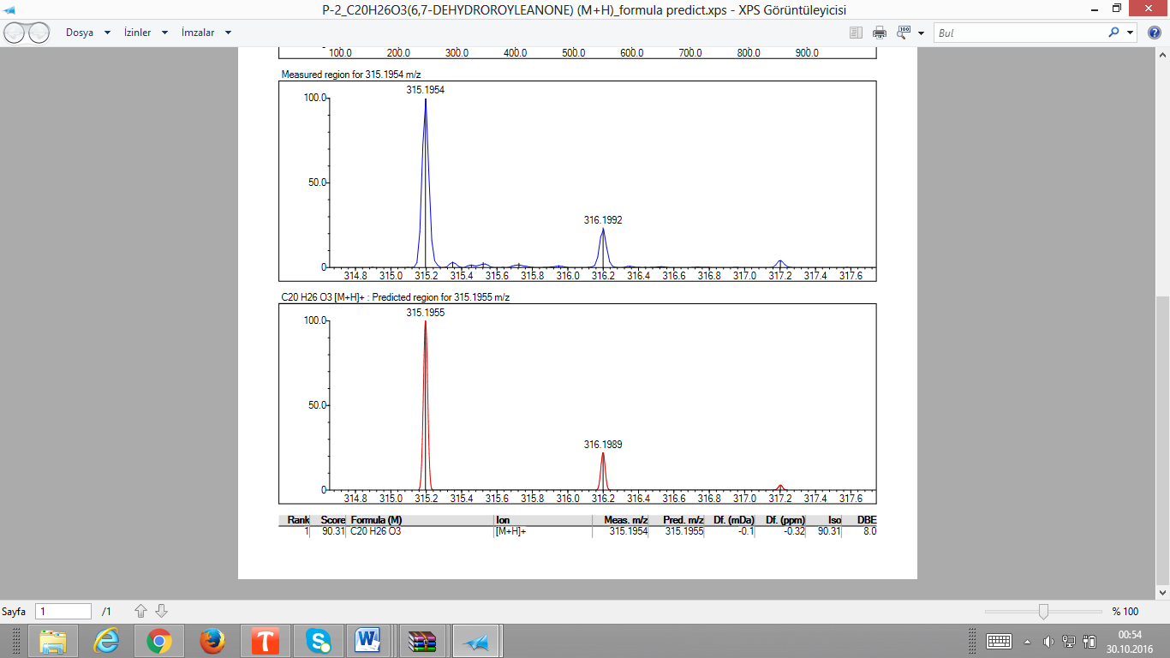
Figure S48. LC-MS-IT-TOF spectrum of 11

Figure S49. IR spectrum of 11

Figure S50. ¹H NMR spectrum of 12 in CDCl₃ (600 MHz)

Figure S51. ¹³C NMR (APT) spectrum of 12 in CDCl₃ (150 MHz)

Figure S52. HMBC spectrum of 12 in CDCl₃ (600 MHz)

Figure S53. HMQC spectrum of 12 in CDCl₃ (600 MHz)

Figure S54. GC-MS spectrum of 12

Figure S55. LC-MS-IT-TOF spectrum of 12

Figure S56. ¹H NMR spectrum of 13 in CDCl₃ (600 MHz)

Figure S57. ¹³C NMR (APT) spectrum of 13 in CDCl₃ (150 MHz)

Figure S58. GC-MS spectrum of 13

Figure S59. LC-MS-IT-TOF spectrum of 13

Figure S60. ¹H NMR spectrum of 14 in CDCl₃ (600 MHz)

Figure S61. GC-MS spectrum of 14

Figure S62. LC-APCI-MSI spectrum of 14 (NEG)

Figure S63. ¹H NMR spectrum of 15 in CDCl₃ (600 MHz)

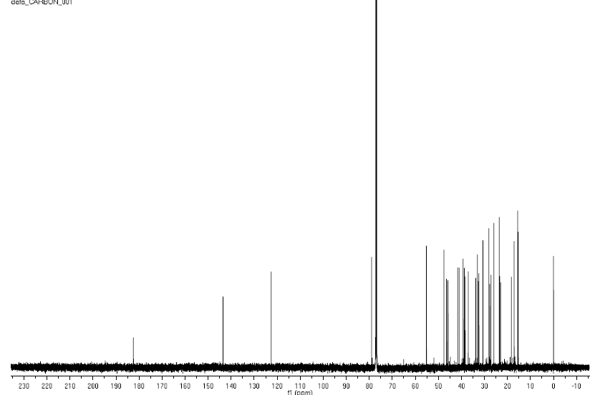
Figure S64. ¹³C NMR spectrum of 15 in CDCl₃ (125 MHz)

Figure S65. LC-MS-IT-TOF spectrum of 15

Figure S66. ¹H NMR spectrum of 16 in CDCl₃ (600 MHz)

Figure S67. ¹³C NMR (APT) spectrum of 16 in CDCl₃ (600 MHz)

Figure S68. LC-MS-IT-TOF spectrum of 16

Figure S69. IR spectrum of 16

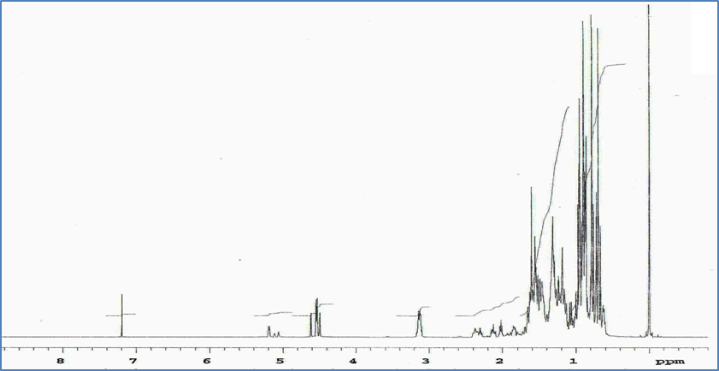
Figure S70. ¹H NMR spectrum of 17 in CDCl₃ (400 MHz)

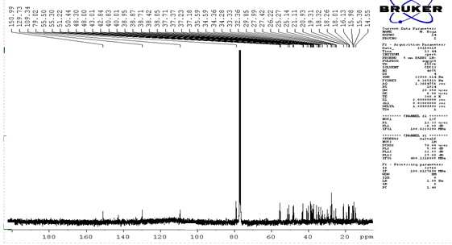
Figure S71. ¹³C NMR spectrum of 17 in CDCl₃ (400 MHz)

Figure S72. ¹³C NMR (APT) spectrum of 17 in CDCl₃ (150 MHz)

Figure S73. GC-MS spectrum of 17

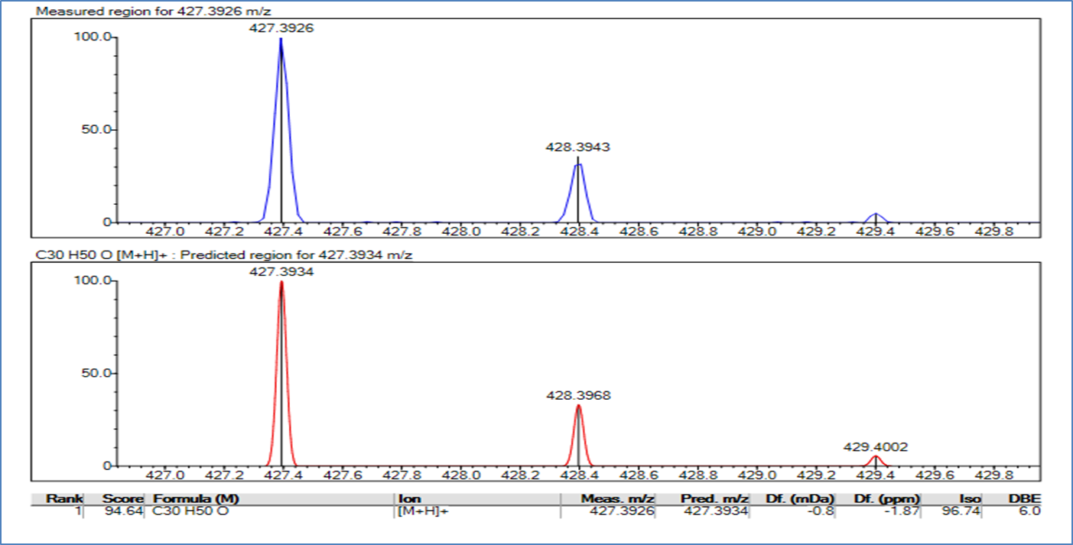
Figure S74. LC-MS-IT-TOF spectrum of 17

Figure S75. ¹H NMR spectrum of 18 in CDCl₃ (600 MHz)

Figure S76. ¹³C NMR (APT) spectrum of 18 in CDCl₃ (150 MHz)

Figure S77. GC-MS spectrum of 18
Figure S78. LC-MS-IT-TOF spectrum of 18

Figure S79. IR spectrum of 18

Figure S80. ¹H NMR spectrum of 19 in CDCl₃ (600 MHz)

Figure S81. ¹³C NMR spectrum of 19 in CDCl₃ (150 MHz)

Figure S82. HMBC spectrum of 19 in CDCl₃ (600 MHz)

Figure S83. HMQC spectrum of 19 in CDCl₃ (600 MHz)

Figure S84. ¹³C NMR (APT) spectrum of 19 in CDCl₃ (150 MHz)

Figure S85. GC-MS spectrum of 19

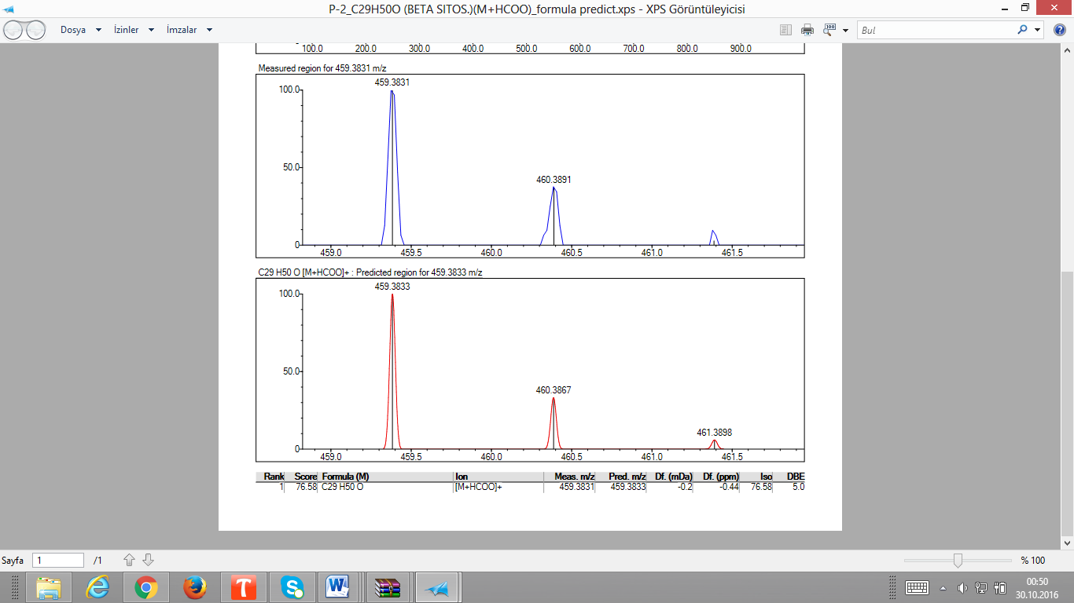
Figure S86. LC-MS-IT-TOF spectrum of 19

Figure S87. ¹H NMR spectrum of 20 in CDCl₃ (600 MHz)

Figure S88. ¹³C NMR (APT) spectrum of 20 in CDCl₃ (150 MHz)

Figure S89. LC-MS-IT-TOF spectrum of 20

